Submit a single PDF to Canvas.

**Problem 1 (12 points)**

Transform the following ER diagram for an SNL database into a set of relational schema, include primary & foreign keys.

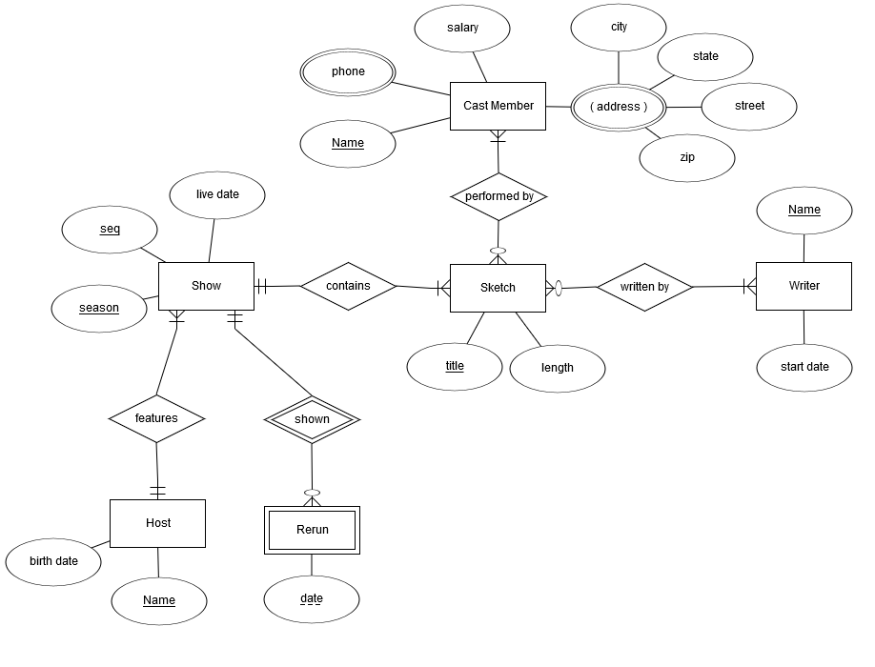

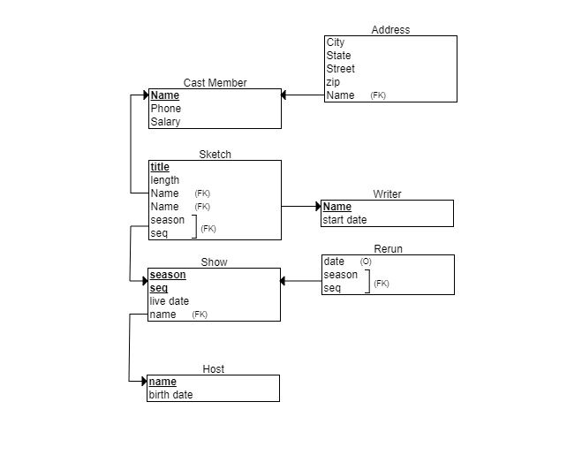

**Problem 2** **(8 points)**

Transform the following ER diagram for Vacation Property Rentals into a set of relational schema, include primary & foreign keys.

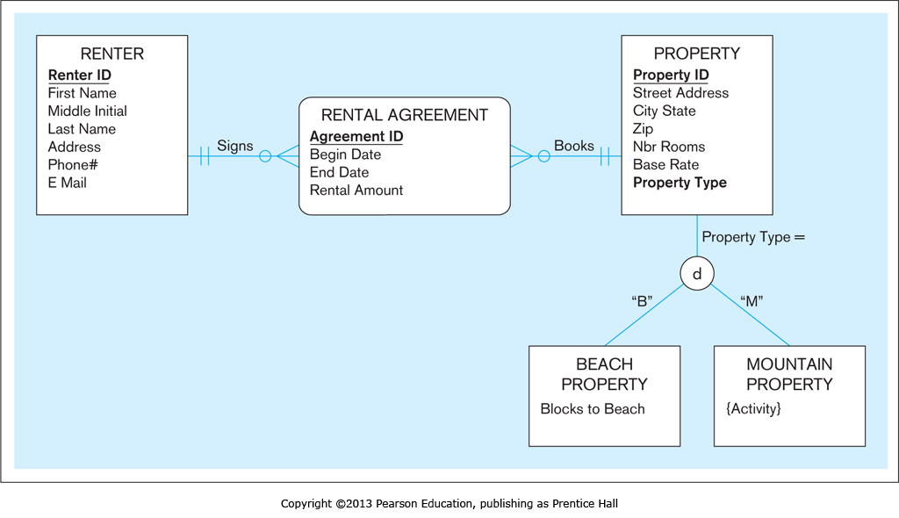

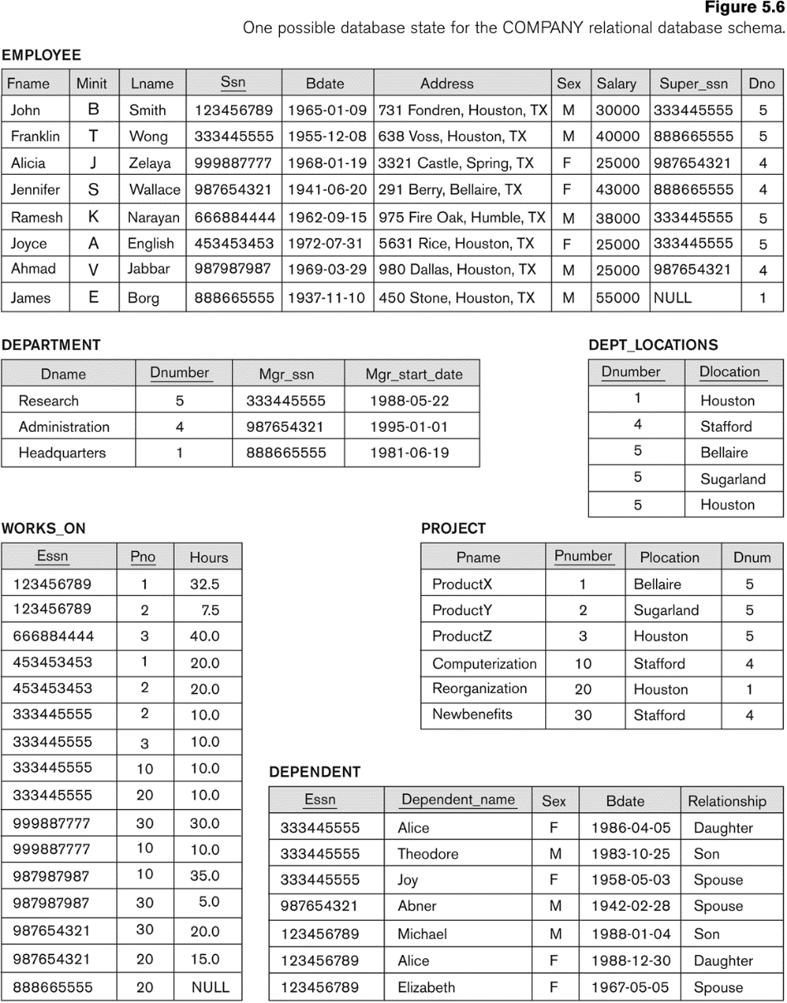

**Problem 3: (10 points)** Suppose each of the following Update operations is applied directly to the database above. Discuss *all* integrity constraints (key, entity, domain & referential) violated by each operation, if any, and the different ways of enforcing these constraints:

1. **Insert < 'Robert', 'F', 'Scott', '943775543', '1962-12-20', '2365 Newcastle Rd, Bellaire, TX', M, 58000, '888665555', 1 > into EMPLOYEE.**

No violations

1. **Insert < 'ProductA', 4, 'Bellaire', 2 > into PROJECT.**

violation, referential integrity

Referential Integrity:

No turple in department relation with dnumber = 2 exists

How to fix:

Create new tuple dnum = 2 for the department itself

Change dnum to 1, 4, or 5

1. **Insert < 'Production', 4, '943775543', '2010-06-21' > into DEPARTMENT.**

Violation, Key constraint, and referential integrity

Key Constraint:

Dnumber 4 already exists in the department tuple.

Way to fix:

Change value of dnumber to not violate existing key constraint

Referential Integrity:

No tuple exists in the employee relation with ssn='943775543'.

Way to fix:

change the value of mgrssn to an existing ssn value in

employee, Or Inserting a new employee tuple with their ssn='943775543'.

1. **Insert < '677678989', null, '40.0' > into WORKS_ON.**

Violation of the entity, and the referential integrity

Entity:

Pno cannot be null, because it is a primary key in works_on

Way to fix:

Change pno value, also pnumber should be in the project relation.

Referential:

No tuple with employee ssn '677678989' exists

Way to fix:

Change essn to existing ssn value that is within employee, or insert a new employee tuple with the ssn '677678989'

1. **Insert < '123456789', 'Emma', F, `Jan 15th 1980`, 'Spouse' > into DEPENDENT.**

No violations

1. **Delete the EMPLOYEE tuple with SSN= '987654321'.**

Violations, Referential integrity

Many tuples exist in the other tables that reference the tuple that we are trying to delete from employee

Way to fix:

Deleting all tuples in the WORKS_ON, DEPENDENT, DEPARTMENT, and EMPLOYEE

relations whose values for ESSN, ESSN, MGRSSN, and SUPERSSN.

1. **Modify the MGRSSN and MGRSTARTDATE of the DEPARTMENT tuple with DNUMBER=5 to '123456789' and '1988-10-01', respectively.**

No violation